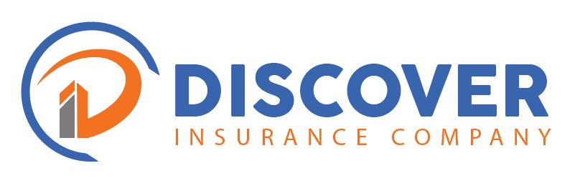

TO: PROFESSIONAL OUTCOMES LIMITED
OCCUPATION: TBA
FROM: DISCOVER INSURANCE COMPANY
DATE: 21th AUGUST 2025
AGENT: DIRECT
PERIOD: TBA

QUOTATION VALIDITY PERIOD:
Fourteen Days (14). This is a quotation only, and it is not the intention to HOLD COVERED unless specifically endorsed in writing.
CLASS: BID BOND.
________________________________________________________________________
We refer to your above request and based on the information provided we are glad to quote as below.
We trust you will find this to be in order and should you wish to discuss our quotation, please do not hesitate to contact us.
Kind regards,

Cecilia Kalenga
Underwriter
Discover Insurance Company
E-mail: cecilia@discoverinsurance.co.zm

BID BONDTE CUSTOMS BOND.
Contract: TENDER FOR SUPPLY AND DELIVERY OF THERMOPLASTIC ROAD
MARKING PAINT (10 LOTS)
Tender Number: RDA/ONB/ORD/001/025/2
Bid Value: ZMW79, 215, 404.51
2% of the Bid: ZMW1, 600,000.00
Duration; Tba
Premium: ZMW8000
Levy: ZMW400

Total Premium: ZMW8,400

